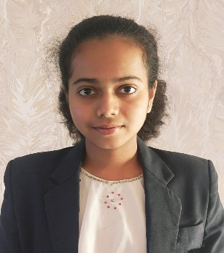BHOOMIKA N

Email[: bhoomika071625@gmail.com](mailto::%20bhoomika071625@gmail.com)

Student email: [bnarasim@gitam.in](mailto:bnarasim@gitam.in)

Phone number: 8971614968

Linkedin: [linkedin.com/in/bhoomika-n-277b7425](https://www.linkedin.com/in/bhoomika-n-277b74256)

Address: Benaka Layout, Near Nelamangala Bypass, Nelamangala Town -562123, Bengaluru Rural district ,Karnataka State

Career Objective:

Electronics and communication engineering student with a solid academics, excellent communication skills, team management. Attended workshops and hands-on experience. Committed to the meeting organizational objectives and producing high quality results. Technical expertise to seek and passion for innovation in challenging professional setting.

Education:

B. Tech| ELECTRONICS AND COMMUNICATION ENGINEERING | BENGALURU

Gandhi Institute of Technology| Graduation: 2025|CGPA: 8.7

PRE UNIVERSITY| STATE CURRICULUM | BENGALURU

Narayana PU College |Year of passing: 2021|Percentage: 95.2%

SCHOOL|CENTRAL BOARD OF SECONDARY EDUCATION | BENGALURU

MSV Public School| Year of passing: 2019|Percentage: 91.2%

Technical skills :

Proficient in C programming

Python programming and data structures in python programming.

Familiar with MATLAB coding, Simulink, Logisim, cadence, Xilinx Vivado.

Soft skills:

Good in communication, decision making, team player, consistent, dedicated.

Skills and Competencies Document:

CMOS digital IC design workshop - Cadence virtuoso tool uses and simulation

procedures was done.(19/02/2024 to 23/02/2024)

Fundamentals of c programming – Completed the program tasks and attended one week course of C programming. (31/01/2024)

Introduction to cybersecurity – In Cisco networking academy, the basics of cybersecurity course was completed. (Jul-Oct 2023)

Basic Environmental Engineering and Pollution Abatement: In NPTEL, the causes of pollution to the environment course was completed with the span of 12 weeks. (24/08/2023)

IBM Skills Build - Completion of Project Management Fundamentals. (24/08/2023)

Arduino based Electronic robot, obstacle avoider, the robot was made to detect the obstacle and avoid colliding with the obstacle ahead using sensors.

Internships:

Embedded developer virtual internship, AICTE – Eduskills, supported by MICROCHIP, span of 1 week. Basics of microcontrollers and the bitwise operation in microcontrollers. Understanding the microcontroller procedures and also the hardware kit and architecture of the microcontroller. By completing all the tasks assigned and earning a certificate.

Languages Known:

English, Hindi, Kannada

Achievements :

Secured 1st place at the dance competition in Annual Training Camp- (2023)

Participated in Inter Battalion Competition. (2023)

Extracurricular activities:

Member in IEEE student chapter - GITAM

Rank holder in NATIONAL CADET CORPS, with the rank of SERGEANT- (2021-2024)

Member in the dance group Starbursts

Declaration:

I hereby declare that all the details mentioned above are by the truth and fact as per my knowledge and I hold the responsibility for the correctness of the above-mentioned particulars.